Workflows and activities at FIELD FUNCTIONARY (AWW/ASHA) level
Functionalities available in the Field functionary (AWW/ASHA) Login (THE MAKER)
On the PMMVY app, the AWW/ASHA login (Maker role) includes functionalities related to data entry, beneficiary tracking, and reporting. Under data entry, they can register beneficiaries, access due lists from POSHAN Tracker, complete facial recognition (FRS), check NPCI mapping status, update childbirth and immunization details, close cases, update worker profiles (of self), and add Aadhaar details for pre-registered beneficiaries. The screen also provides options to search beneficiaries and access reports such as pendency status, implementation status, ongoing beneficiary analysis, bank account–Aadhaar mapping status, eligibility analysis, and child birthplace details.

Data Entry
- Beneficiary Registration
- Due List of Potential beneficiaries from POSHAN Tracker
- Check Facial Recognition through POSHAN Tracker of pre-registered Beneficiary
- Check NPCI Mapping Status of pre-registered Beneficiary
- Check NPCI Mapping Status Against Aadhar Deseeded
- Update Childbirth and Immunization details
- Update Childbirth and Immunization for Second Girl Child
- Case Closure
- Add AWW/ASHA Worker Profile
- Add Aadhaar Against Pre-Registered Beneficiary
Search Beneficiary
Reports
- Pendency Status
- PMMVY Implementation Status
- Analysis of no. of ongoing Beneficiaries in Anganwadi
- Beneficiary Whose Bank Account need to be mapped with Aadhaar
- Analysis of Eligibility Criteria
- Child-Birth Place
Help

2. Overview of Beneficiary Identification & Registration workflow
Under the PMMVY scheme, every Anganwadi Worker (AWW) and/or ASHA is responsible for ensuring that all eligible Pregnant and Lactating Women (PLWs) in their catchment area are registered at the earliest. Timely registration (at first ANC check-up/12 weeks of pregnancy) is essential to ensure that beneficiaries are enrolled in the system without delay and are able to receive scheme benefits as per eligibility.
2.1 Registration process
To initiate the registration process, the AWW or ASHA must open the PMMVY mobile application or access the PMMVY portal through a web browser. They must log in using their assigned unique user ID and password. After entering the login credentials, an OTP will be generated and sent for authentication. The OTP must be entered to successfully access the system dashboard.
After successful login, there are two ways to register a beneficiary in the system.
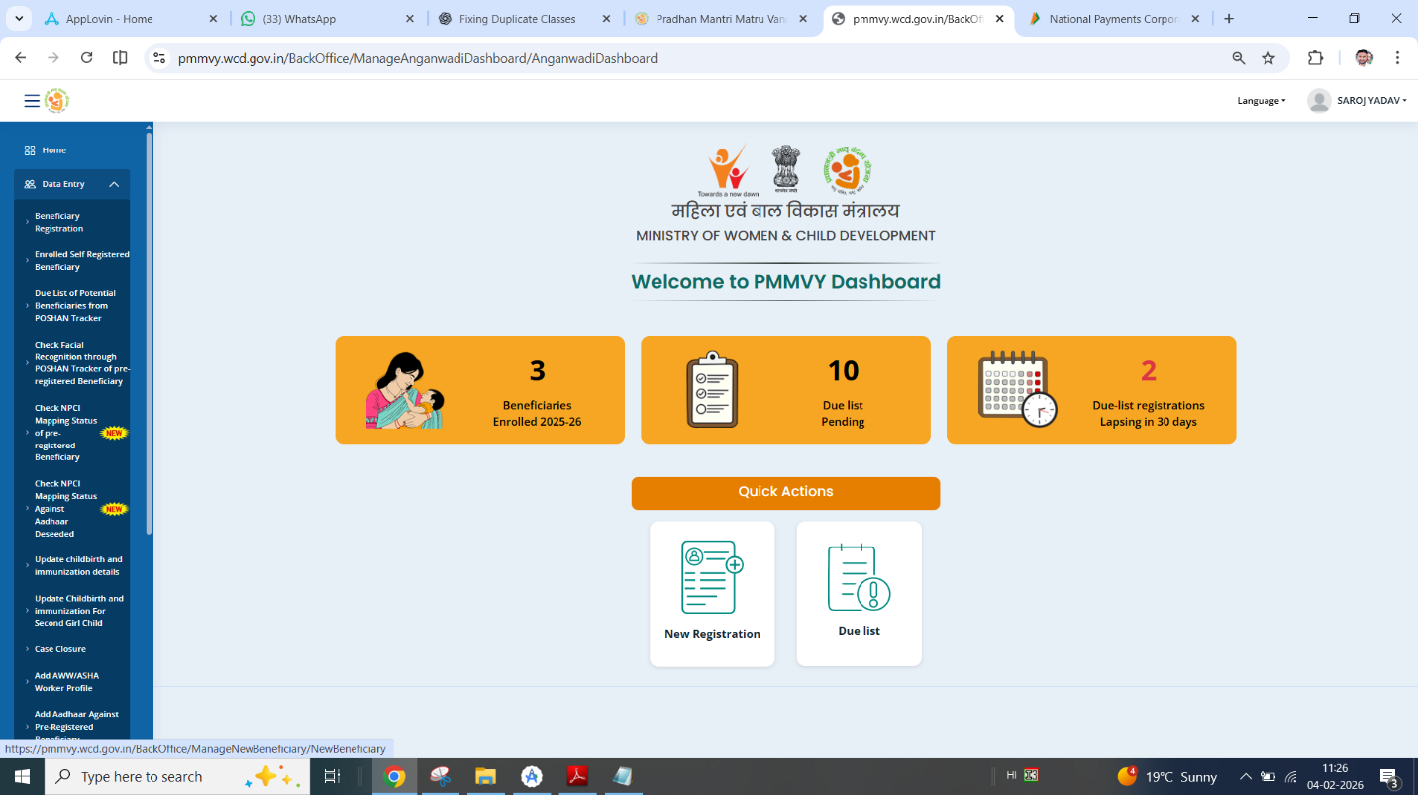
- The first method is through the “New Beneficiary” option. This method should be used when the eligible PLW is not already listed in the system. The AWW or ASHA must carefully enter all required beneficiary details in the prescribed fields and review the information before final submission to ensure accuracy.
- The second method is through the “Poshan Tracker Due-List” option. This method should be used when the beneficiary’s details are already available in the Poshan Tracker system. The AWW or ASHA can select the beneficiary from the due-list and proceed with completing the registration process as required.
AWWs and ASHAs must ensure that the appropriate registration pathway is selected based on the beneficiary’s status in the system and that all information entered is correct and complete before submission.
New Beneficiary Registration
Every Anganwadi Worker (AWW) and/or ASHA is required to register eligible beneficiaries under PMMVY using the New Beneficiary Registration option when the beneficiary is not already available in the system. After logging into the PMMVY application or web portal and reaching the home page, open the Beneficiary Registration Form to begin registering a new beneficiary. Once the form opens, it must be completed in three parts: Beneficiary Details, Face Authentication, and Upload of Eligibility Documents.
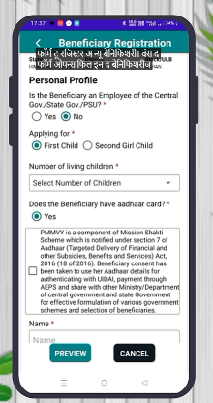
Part 1: Beneficiary Details

- Tick the check-box for Aadhaar data collection.
- Enter the beneficiary’s name and Aadhaar number. Ensure that the name entered is exactly the same as mentioned in the bank account and Aadhaar ID.

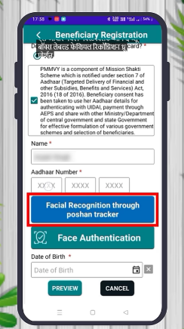
Part 2: Face Authentication (FRS or In-App Face Authentication)
For facial recognition linked to the POSHAN Tracker, click the blue box icon. After clicking, a backend process will start. If the beneficiary has already been authenticated on POSHAN Tracker, a message box will appear with the confirmation message and an OK button.

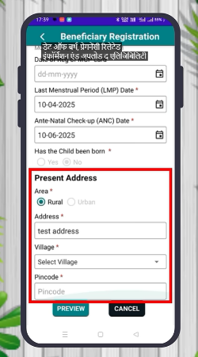
After authentication, fill additional beneficiary details including date of birth, LMP date, ANC date, and address.

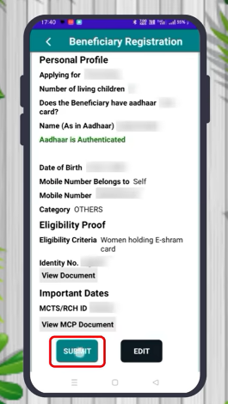
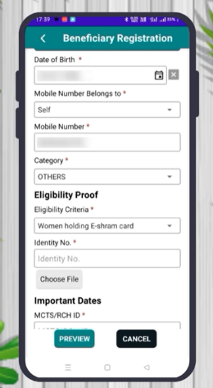
Part 3: Upload Eligibility Document
- Select the eligibility criteria* from the drop-down list.
- Upload the document for the selected option.
- Enter the MCP/MCTS/RCH card number and upload the MCP card.
- After completing all required fields, click Submit.

If all details are complete and FRS is approved, the beneficiary will be enrolled immediately.
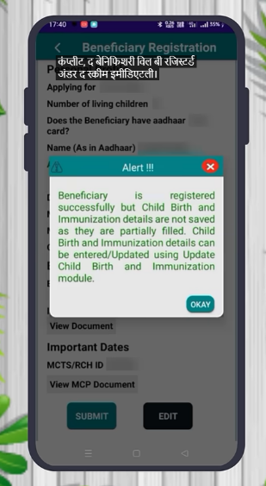
Video Link: https://www.youtube.com/watch?v=eiRwL_bVhuw

Key Point to Remember
Submit the form even if the FRS is not complete. In such cases, the beneficiary will be saved under the pre-registered category for future completion.
2.2 Eligibility Criteria

* Eligibility Criteria and Documents
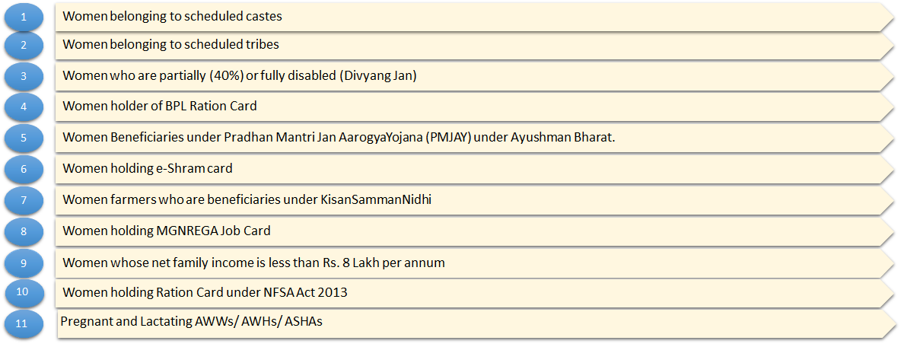
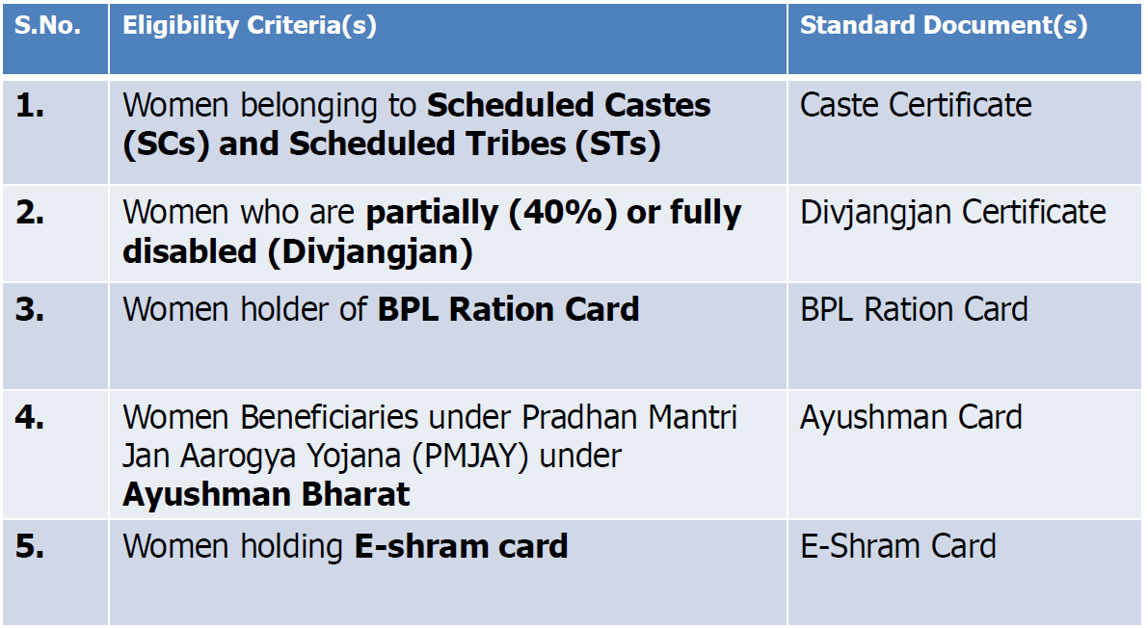
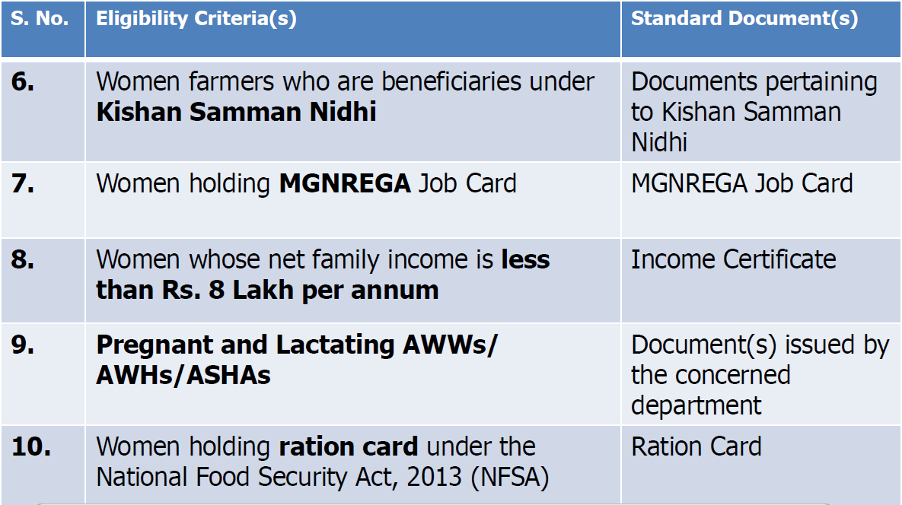

POSHAN Tracker Due List
This section explains the step-by-step process for registering or rejecting beneficiaries received from the POSHAN Tracker Due-List in the PMMVY application.

Step 1: Login to the PMMVY Application
Open the PMMVY app on your mobile phone. Enter your user ID and password and tap on the Login button. An OTP will be sent to your registered mobile number. Enter the OTP and tap on Validate to access the dashboard.
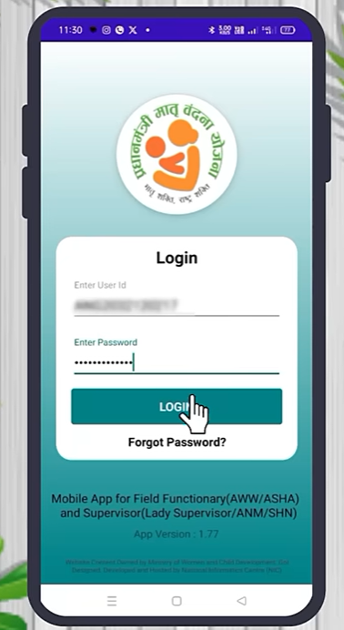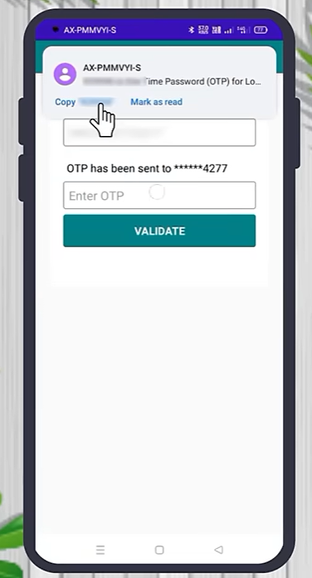

Step 2: Access the Due-List Section
After successful login, scroll down to the Data Entry section. Tap on the orange highlighted option titled “Due List of Potential Beneficiaries from POSHAN Tracker.”
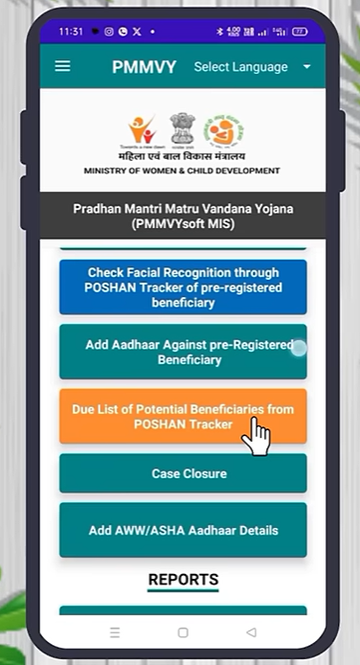

Step 3: View List of Potential Beneficiaries
The screen will display potential beneficiaries of the PMMVY scheme who have been sent from the POSHAN Tracker to your PMMVY app.
Basic details of each beneficiary will be shown, including name, child order, Anganwadi details, and beneficiary type. Two options will be available for each beneficiary: Register and Reject.
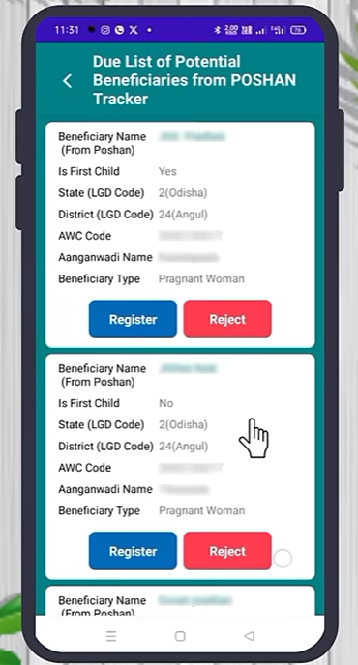

Step 4: Register an Eligible Beneficiary
If the beneficiary is eligible under PMMVY and has not been registered previously, click on Register.
Confirm important details such as:
- Whether the beneficiary is a government functionary
- Number of children
- Aadhaar number
- Date of birth
- Pregnancy-related information
- Eligibility documents
- Address
After confirming the details, complete the face verification process (already completed when registering through POSHAN) and click Submit.
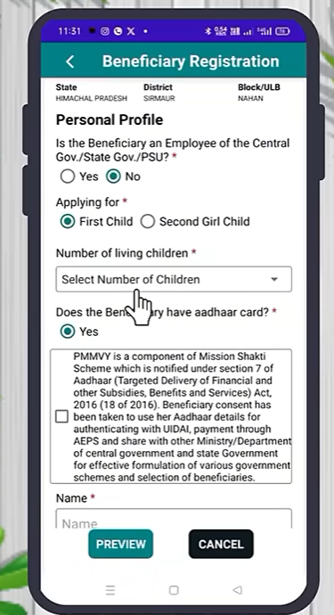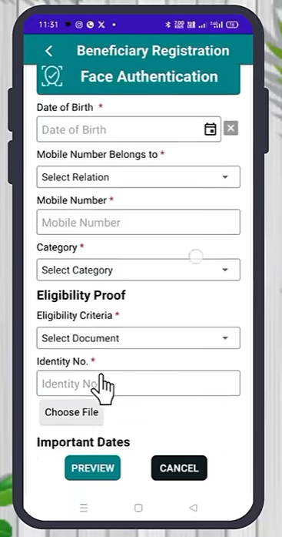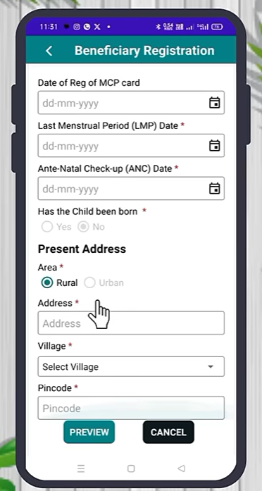

Step 5: Reject an Ineligible or Duplicate Beneficiary
If the beneficiary is already registered, is a duplicate entry, is not eligible under the scheme, or does not belong to your center, click on Reject.
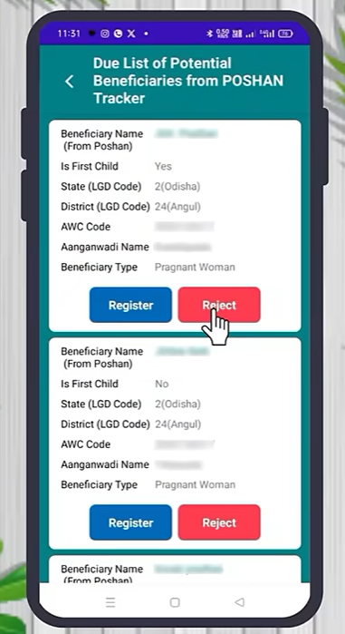
To proceed with rejection, select the appropriate reason from the drop-down menu, such as “Not eligible Beneficiary,” and click Submit. A confirmation pop-up message will appear. Click OK to confirm the rejection.
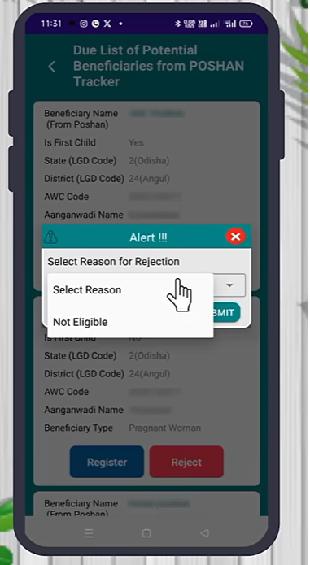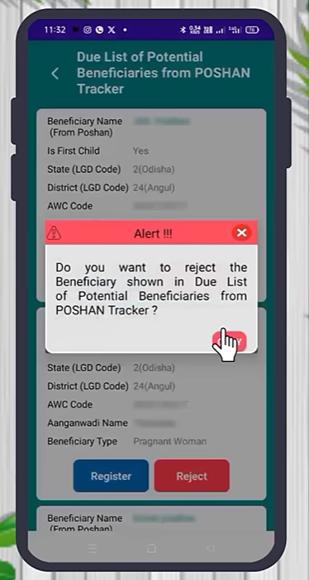

Once confirmed, the beneficiary will be marked as rejected in the system.
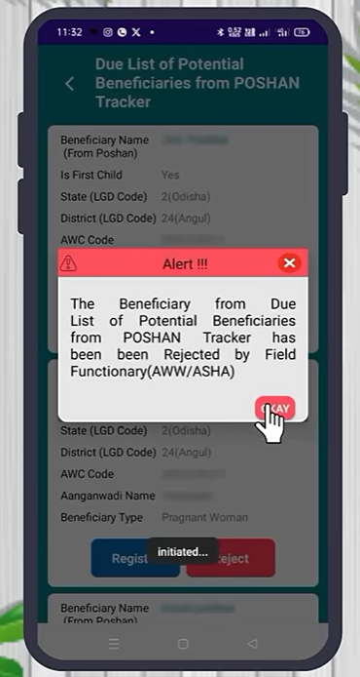

2.3 Facial Recognition Process
Facial Recognition is a mandatory step in the PMMVY process to ensure Aadhaar-based authentication of beneficiaries. Completion of face verification is directly linked to payment processing. If face verification is completed, payment will be credited. If face verification is not completed, payment will not be released. Therefore, every Anganwadi Worker must regularly check the facial verification status of beneficiaries and ensure that pending cases are completed.
There are two processes under Facial Recognition:
- Checking Facial Recognition (FRS) through POSHAN Tracker
- Face Authentication of Beneficiary in PMMVY App

Facial Recognition (FRS) through POSHAN Tracker
The following process explains how to check Facial Recognition (FRS) status through POSHAN Tracker using the PMMVY App or Website.

Step 1: Open PMMVY App or Website
Option 1: Through Mobile App
- Open the PMMVY Application. (this can be downloaded from Appstore or PMMVY website – youtube links )
- Enter your User ID and Password.
- Click on Login.
Option 2: Through Website
- Open Google / Chrome.
- Search for PMMVY.
- Open the official website: www.PMMVY.wcd.gov.in
- Enter your Login ID and Password.
- Click on Login.

Step 2: OTP Verification
- An OTP will be sent to your registered mobile number.
- Enter the OTP.
- Click on Validate.

Step 3: Open Face Recognition (via POSHAN Tracker)
- After successful login, open the available options.
- Click on “Face Recognition (via Poshan Tracker)” option.
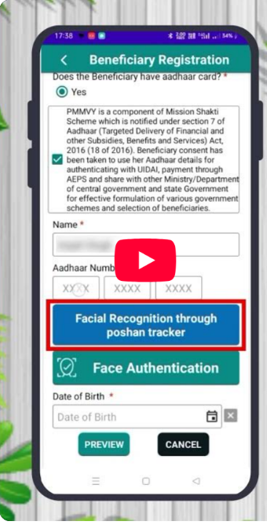

Step 4: Check Beneficiary List
- The list of beneficiaries will be displayed.
- Names will appear with numbering.
- The status of face capture will be shown against each beneficiary.
- Scroll to view all beneficiaries.
- It will indicate:
  - Whose face is captured
  - Whose face is pending
This process helps in identifying beneficiaries whose Facial Recognition (FRS) is pending and requires completion.

Note: If Facial Recognition (FRS) continues to show as pending even after face capture through POSHAN Tracker, the authentication should be completed through Face Authentication in the PMMVY App. For this, ensure that both the PMMVY App and the Aadhaar Face Recognition App are installed from the Play Store or the official website link. Only beneficiaries still showing as pending should be completed using this face authentication process.
Face Authentication of Beneficiary in PMMVY App
The following process explains how to complete Face Authentication of Field Functionaries in the PMMVY Mobile Application.
Step 1: Open PMMVY App
- Open the PMMVY Application.
- Enter your User ID and Password.
- Click on Login.

Step 2: OTP Verification
- After login, an OTP will be sent to your registered mobile number.
- Enter the OTP.
- Click on Validate.

Step 3: Open Face Authentication Section
- After successful login, the dashboard will open.
- Click on “Face Authentication of Field Functionary” (pink background option).
- The list of Anganwadi Workers will appear.

Step 4: Select Worker for Authentication
- Click on Face Authentication next to the worker’s name.
- Click OK.
- Turn ON your Location when prompted.

Step 5: Give Permissions
- Processing will start.
- Tick the permission checkbox.
- Click on Proceed.
Step 6: Capture Photo Properly
The following instructions must be carefully followed:
- By default, the front camera opens. Switch to the back camera.
- Ensure proper lighting.
- Ensure a plain background.
- The worker’s face should be straight.
- Eyes should be open and blinking.
- When the face fits correctly within the frame, the frame will turn green.
- This indicates that the face has been properly captured.

Step 7: Processing and Verification
- After capturing the image, processing will begin.
- If successful, the message will show:
“Face Successfully Authenticated.”
- Click OK.
- Wait for 1–2 seconds.
- A confirmation message will appear:
“Data Inserted.”

If Face is Not Verified
If the message shows “Face Not Authenticated,” then:
- Take the photo again carefully.
- Ensure proper lighting and clarity.
- If authentication continues to fail, ask the worker to check and update Aadhaar details.

After Successful Authentication
Once a beneficiary’s face is successfully authenticated:
- The beneficiary name will automatically disappear from the list.
- Only beneficiary with pending authentication will remain visible.

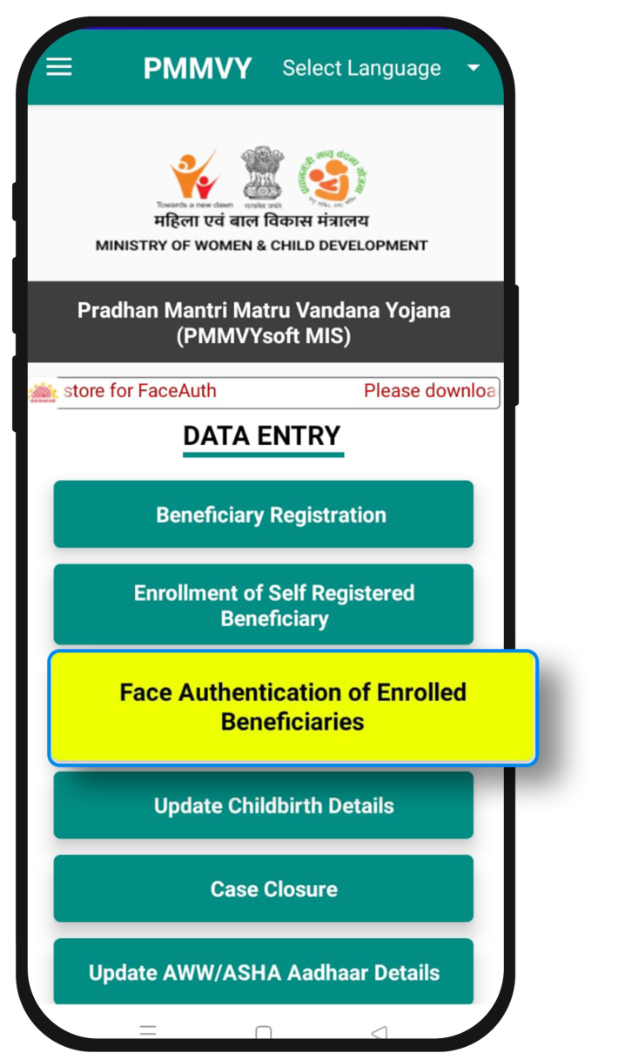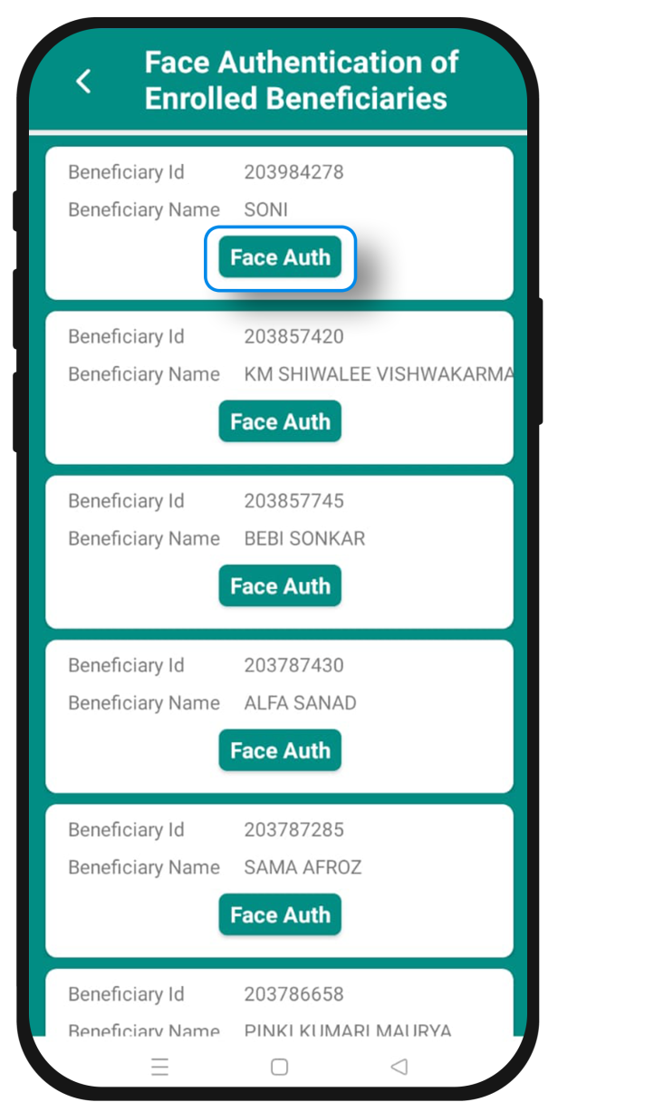

2.4 Linking Aadhar and bank account (Aadhaar seeding/ NPCI mapping)
For receiving benefits under Direct Benefit Transfer (DBT) schemes, including PMMVY, it is essential that the beneficiary’s bank account is Aadhaar-seeded and NPCI-mapped. Aadhaar seeding links the Aadhaar number with the bank account, and NPCI mapping ensures that DBT payments are routed correctly through the Aadhaar Payment Bridge (APB) system. Without proper seeding and mapping, benefit transfers may fail or remain pending. The following section explains the complete process for initiating Aadhaar seeding through the NPCI website.

Step 1: Open NPCI Website
- Open internet browser on mobile or computer.
- In Google search, type NPCI.
- Open the official website of National Payments Corporation of India (NPCI).
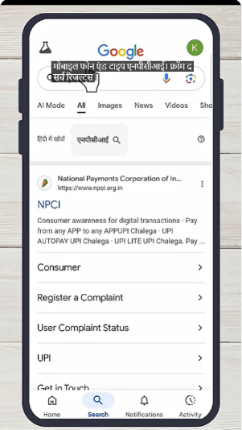
Step 2: Open Consumer Section
- On the homepage, click on Consumer.
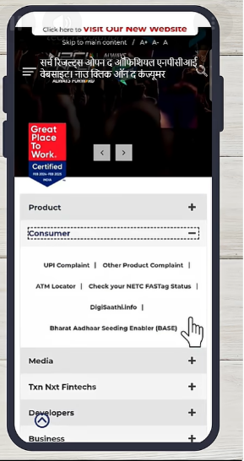

Step 3: Open Bharat Aadhaar Seeding Enabler (BASE)
- Under Consumer options, select Bharat Aadhaar Seeding Enabler (BASE).
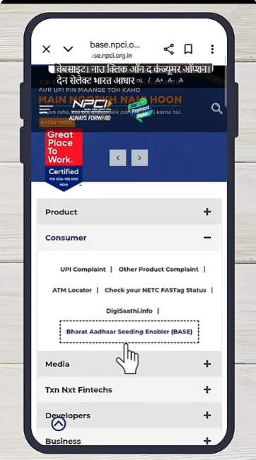
Step 4: Click on Aadhaar Seeding
- Click on Aadhaar Seeding.
- Aadhaar seeding form will open.
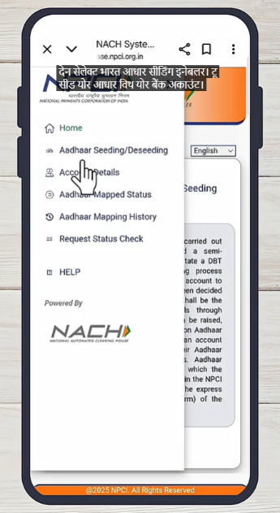
Step 5: Fill Aadhaar Seeding Form
- Enter Aadhaar number.
- Enter Aadhaar seeding name.
- Enter bank account number.
- Tick the checkbox for Terms and Conditions.
- Enter captcha code.
- Click Submit.

Step 6: Accept Consent
- Terms and Conditions page opens.
- Scroll down.
- Click Agree and Continue.

Step 7: OTP Verification
- Enter OTP received on Aadhaar-linked mobile number.
- Click Submit.

Step 8: Aadhaar Seeding Initiated
- Confirmation message appears.
- Aadhaar seeding request is submitted.
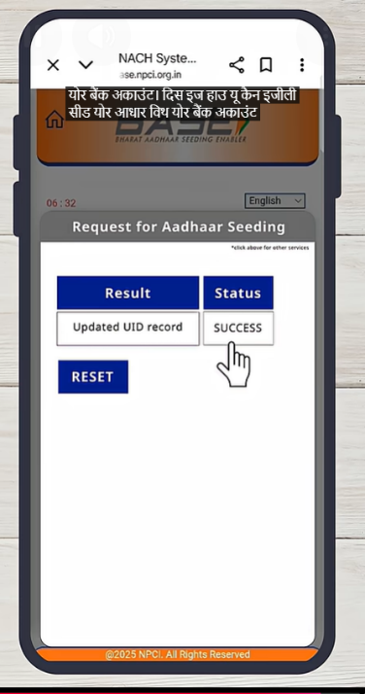

2.5 Reducing pendency and pre-registered beneficiaries
For beneficiaries saved under the pre-registered category, pendency must be cleared by completing:
a. Facial Recognition (FRS).
b. Aadhaar seeding and NPCI mapping.
Both processes must be completed to ensure successful enrollment and payment processing.
2.6 Common issues and checks
Successful registration under PMMVY requires careful verification of eligibility, correct document submission, adherence to system timelines, proper mapping, and completion of authentication processes. Any error in age criteria, Aadhaar authentication, document upload, bank seeding, date validations, or mapping can lead to pendency, rejection, or time-barred cases. Therefore, it is essential to ensure that all required conditions are fulfilled before and during registration.
1. Eligibility and Mandatory Conditions
The following eligibility conditions must be ensured before registering a beneficiary:
- The beneficiary should not be a Central Government, State Government, or PSU employee.
- The age of the beneficiary should be between 18 years & 7 months and less than 55 years at the time of childbirth.
- Date of Birth of the beneficiary is mandatory.
- Aadhaar authentication of the beneficiary is mandatory.
- The beneficiary’s bank account must be Aadhaar-seeded and DBT-enabled.
- The beneficiary must select the applicable category (Others, SC, or ST).
- Mobile numbers are mandatory.
2. Mandatory Document Entry and Upload
To successfully complete the registration form:
  - The identity number of the selected eligibility document must be entered.
  - Uploading the selected eligibility document is mandatory.
Both entry and document upload are required for form completion.
3. Registration Timelines and Date Validations
The beneficiary is eligible for registration in the PMMVY Soft MIS:
- Within 270 days after childbirth, or
- Within 570 days from the Last Menstrual Period (LMP) date.
Childbirth cannot occur before LMP + 140 days (pre-mature) or after LMP + 300 days (post-mature).
Additional date-related validations:
- Beneficiary Registration Date will be the current date.
- Ante-Natal Check-up (ANC) date must be within 180 days from the LMP date.
- Immunization details can be entered only if the child is born and 98 days of the first cycle of immunization have been completed after childbirth.
For second girl child registration:
- Birth and full immunization details must be filled.
- The entire registration, including immunization details, must be completed in one go.
- After submission, the form goes to the Supervisor for verification and then to the Sector Officer (SO) for approval.
4. Verification and Approval Process
At the Supervisor level:
- The form can be marked as Verified or Not Verified.
- In both cases, it is forwarded to the SO for final decision.
At the SO level:
- The form may be Approved or Rejected.
- Rejection must be accompanied by a selected reason.
Reasons for rejection include:
- Fake Beneficiary
- Not eligible
- Documents uploaded are not correct
- Stillbirth
- Already availed full benefit
- Miscarriage
- Death of beneficiary
- Death of child
5. Mapping Requirements
Correct mapping is essential for beneficiary and FLW payments. Mapping refers to linking the detailed address structure of the AWW in the system for payment processing, reporting, and workflow.
Mapping is completed at the state level. However, workers must ensure:
- Issues are raised if mapping is incomplete.
- Required information is shared as applicable.
AWW Address Structure in PMMVY:
District → Block/ULB → Project → Sector → Village/Ward → AWC
The AWW address consists of both WCD and PRI levels.
Types of Mapping
- Mapping with WCD and LGD Hierarchies in PMMVY
  - Lack of mapping creates challenges in user creation, registration, verification, and approval.
  - Mapping is linked with the Incentive Module of AWW. The incentive module becomes functional only after complete and finalized state mapping.
- Mapping AWC Codes with Poshan Tracker
  - Enables transfer and linking of records from Poshan Tracker to PMMVY.
  - Only correctly mapped AWCs receive the Due-List and FRS utility from Poshan Tracker.
6. Time-Lapsed Cases
Beneficiaries who are not registered within 570 days from the LMP date become time-barred and cannot be registered under the scheme.
The Due-List displays the remaining time before a case lapses. AWWs should prioritize cases nearing the lapse deadline and complete necessary actions to avoid time-barred situations.

- Childbirth and Immunisation workflow
Under PMMVY, the AWW/ASHA initiates the process for documenting childbirth and immunization details. Completion of this process leads to processing of the second instalment payment.
Step 1: Access the Data Entry Section
Click on the “Data Entry” tab on the dashboard. A list of options will be displayed. Select the “Update Childbirth and Immunization” option to open the list of beneficiaries for whom childbirth and immunization details are to be filled.
Step 2: Open Beneficiary Form
From the displayed list, click on the “Edit” button against the relevant beneficiary. This will open the beneficiary immunization details form.
Step 3: Enter Immunization Details
Fill in the details of all vaccinations along with the corresponding dates as mentioned in the MCP card. After entering all required information, click Submit.
Step 4: Forward for Verification
After successful update and submission, the application will be forwarded to the LS for verification.
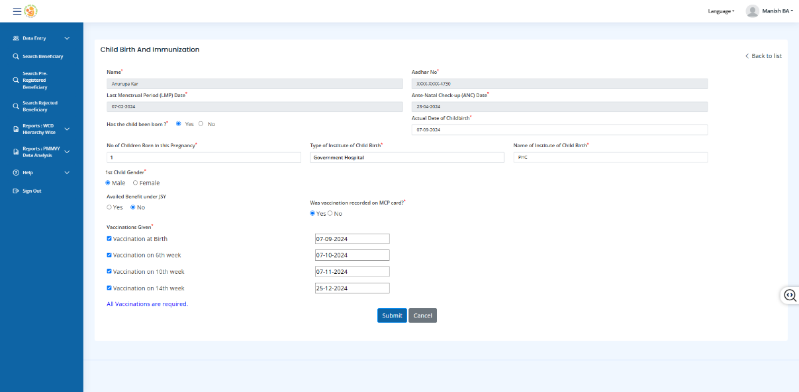

- Case Closure workflow
Under PMMVY, the AWW/ASHA is responsible for initiating and submitting the request for closure of a case in the event of stillbirth, miscarriage, death of the beneficiary, or death of the child (if applicable). In such situations, the AWW/ASHA must ensure that the closure request is raised in the system under the appropriate reason category so that the case can be processed accordingly.
Note: Case closure can be initiated only after the beneficiary registration has been approved at the SO level. This means that the original registration must have completed the approval process at the Sector Officer (SO) level before any closure request can be submitted.
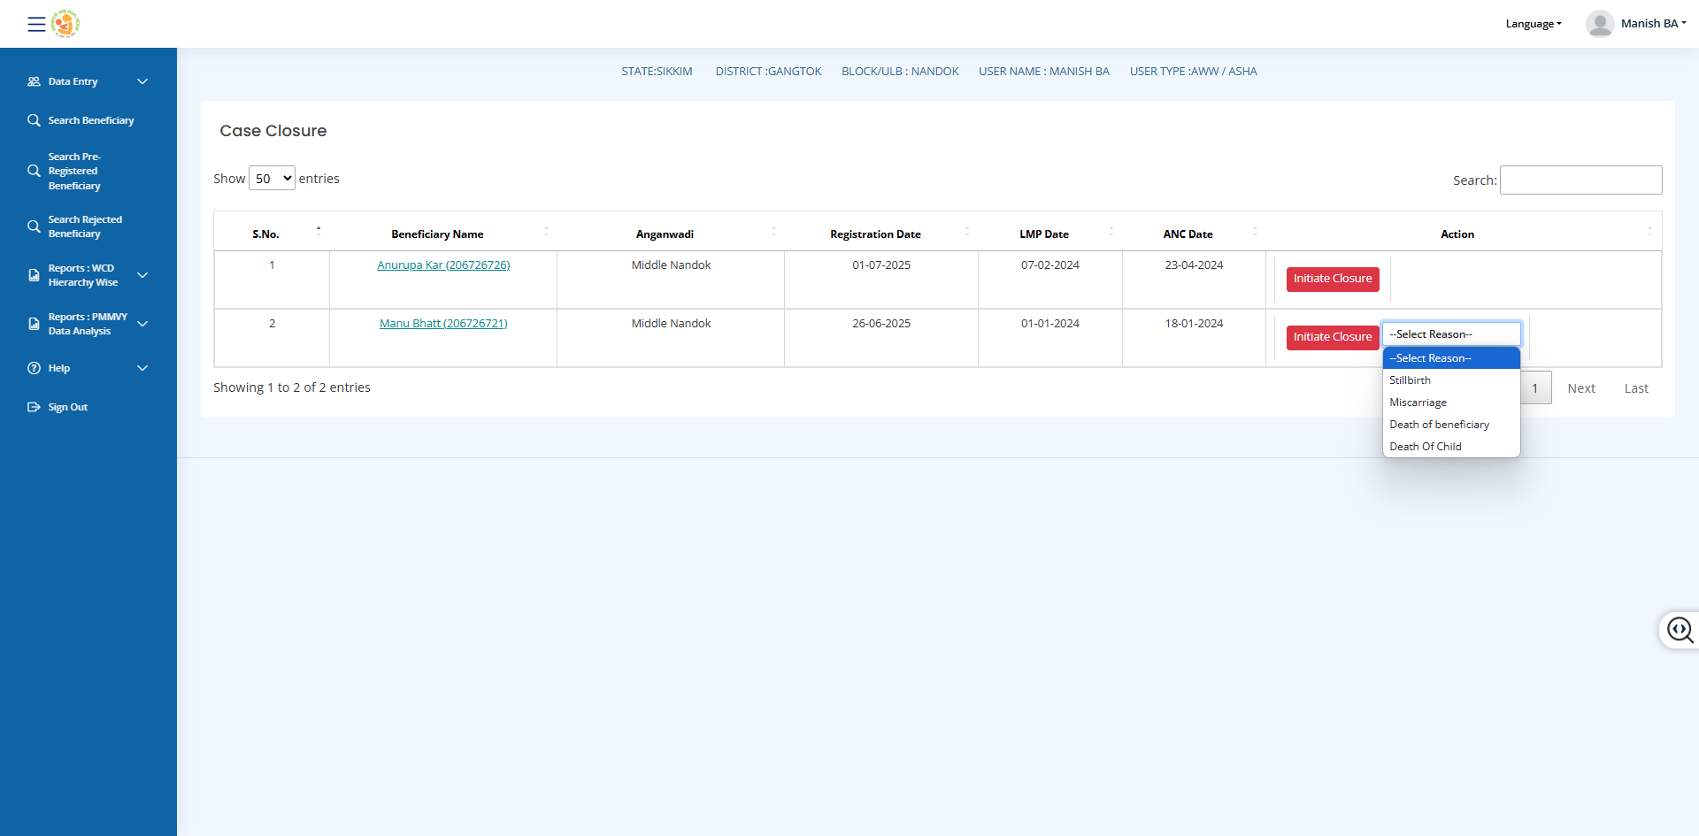

Search Beneficiary
The PMMVY portal provides a functionality of searching for a beneficiary to the worker. The AWW can search for a particular beneficiary by beneficiary ID, Aadhar no OR Mobile number. It is commonly under functionality to track status of the payment or pendency.
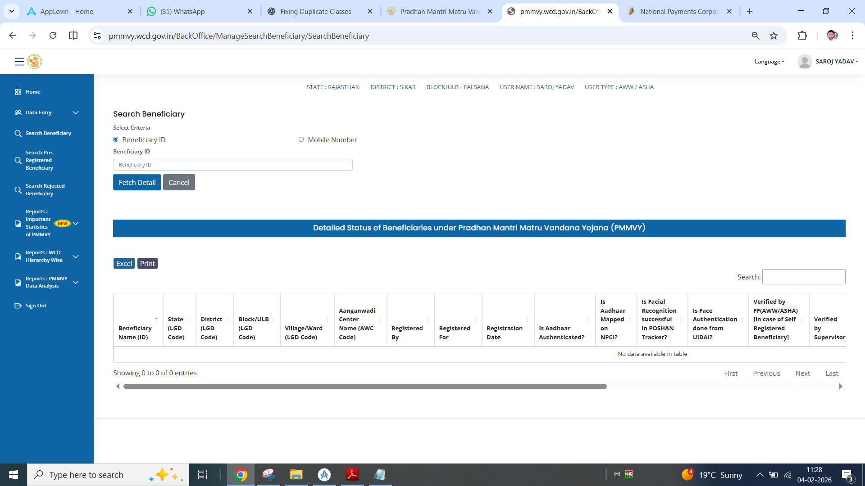

There are 2 reports available on detailed status of - pre-registered and rejected beneficiaries in a table format for AWW view and action.

- Reports (WCD Hierarchy wise)
The AWW/ASHA dashboard is designed to support day-to-day tracking of beneficiaries and payment progress at the field level. It is not meant for high-level analytics, but for operational monitoring at the AWC level. The reports visible to AWW/ASHA focus on registration status, pendency reasons, verification flow, and payment tracking.
The following reports are available on the AWW/ASHA dashboard:
PMMVY Implementation Status (by year)
This report provides a detailed snapshot of AWC-level data for the past three years. It includes the number of beneficiaries entered into the system, number enrolled, and cases pending due to Aadhaar authentication issues, Aadhaar seeding issues, incomplete FRS from POSHAN Tracker, FRS completed but Aadhaar not seeded, verification status, approval status, and payment status. This report helps track the overall implementation progress and identify bottlenecks at different stages.
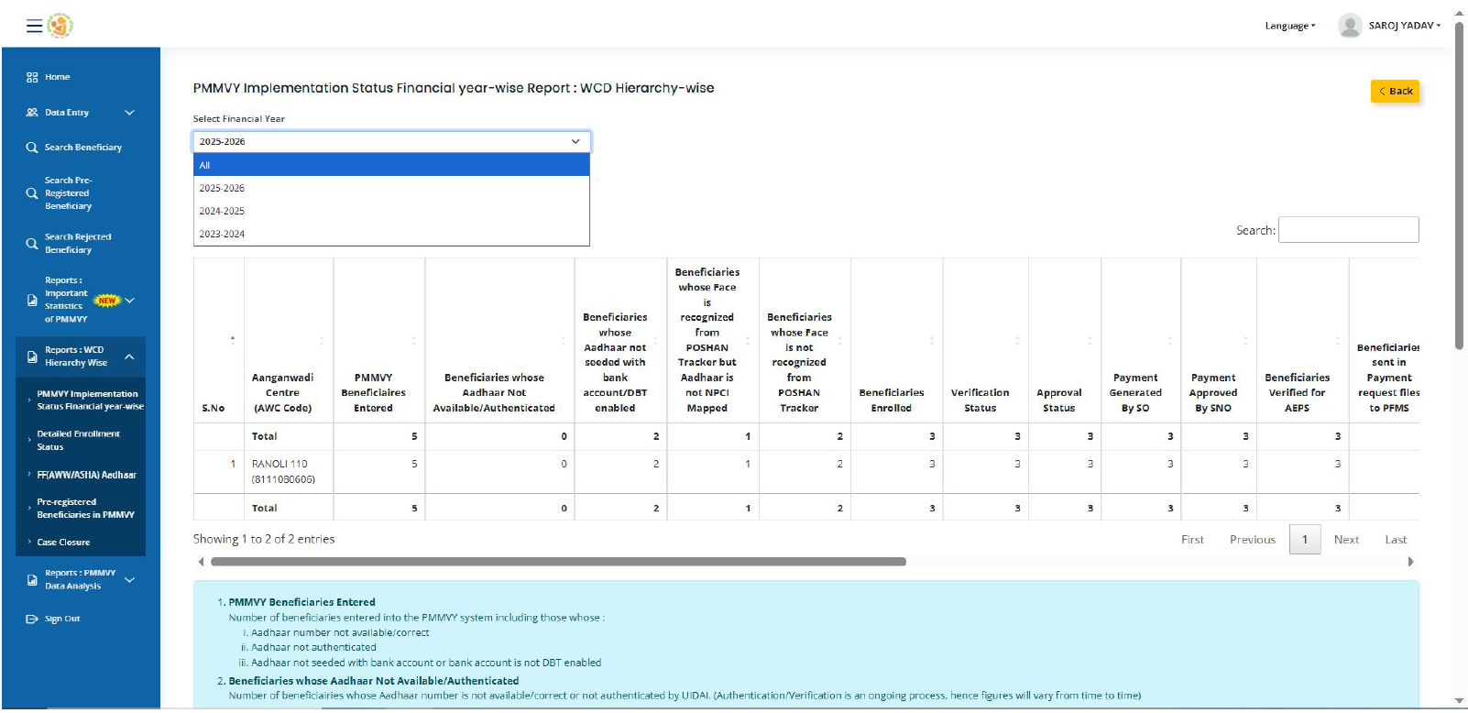

Detailed Enrollment Status
This report shows the number of beneficiaries enrolled by AWC, categorized as first child, second girl child, and total enrollments. It provides a clear view of enrollment distribution at the center level.
Field Functionary Aadhaar
This section displays information related to FF Aadhaar as reflected in the system.

Pre-Registered Beneficiaries in PMMVY
This report shows the number of beneficiaries who are pending completion of registration along with the reason for pendency. By clicking on the hyperlink provided in the report, the detailed list of individual beneficiaries can be accessed for further action and follow-up.
Case Closure
This report >>>>>>><<<<<<<<
PMMVY DATA ANALYSIS

